



**Applications in Practical High-End Computing - Group Project**

Assignment - "Workflow"

**Implementation document**

Supervisor: Dr Stuart Barnes

Authors: Mateusz Gołąb

Csaba Kerti

Jakub Kiełbasa

Zsolt Kollarits

Course: CSTE / SETC

**Table of contents**

1. Introduction 3

2. JAVA Overview 3

a) Why JAVA? 3

b) Compile process 3

c) About JAVA 3

3. Communication with remote server - SSH 4

a) About SSH 4

b) Security of SSH 5

4. Source code examples 5

a) Example 1 5

b) Example 2 6

c) Example 3 6

d) Example 4 7

5. Examples of output 7

a) Output example 1 7

b) Output example 2 8

c) Output example 3 8

d) Output example 4 8

6. References 7

1. Introduction

After taking into consideration all advantages and disadvantages we decided to use JAVA language for implementation and SSH protocol for communication with remote server. In this document we can see an overview about these technologies.

1. Overview of JAVA
2. Why JAVA?

Java is a standard Object Oriented Programming Language and contains all of its benefits: [1]

* supports the construction of programs that consist of collections of collaborating objects
* encapsulation, inheritance, polymorphism
* multithreaded
* robust and secure

But this attributes can be found all modern programming language, so why JAVA? The reason is the **multiplatform** usability. Ideally, this means Java can be developed on any device, compiled into a standard [*bytecode*](http://en.wikipedia.org/wiki/Bytecode) and be expected to run on any device equipped with a [*Java .virtual machine*](http://en.wikipedia.org/wiki/Java_virtual_machine) (JVM). [2]

*Figure 1*: JAVA multiplatform

1. Compile process:

Java compiler will not use the variables and methods for the numerical compiler invoked not sure procedures in the implementation of the memory layout, but these symbols will be used to retain information in the byte code, the explanation for the operation process of creating memory layout, and then look-up table to determine a method of address. This effectively guaranteed the Java portability and security. [3]

1. About JVM:

JVM is designed to provide a description of specifications based on an abstract computer model for the interpretation of the procedures developers provide excellent flexibility, but also ensure that Java code can be in conformity with the norms of running on any system. JVM certain aspects of its realization are given a specific definition, particularly on Java executable code that *bytecode* provided a clear format specifications. The specifications including operation codes and the number of operators and numerical syntax, the numerical identifier that, as well as the Java class files in Java objects, constants in the JVM buffer pool storage mapping. These definitions for the JVM interpreter developers with the necessary information and development environment. [3]

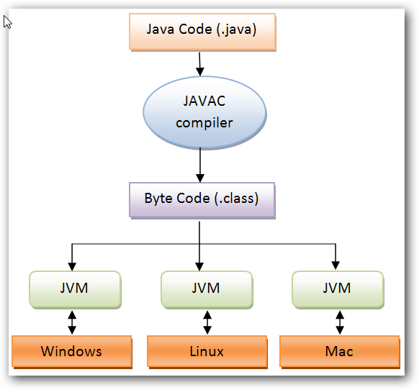Java interpreter running Java byte code equivalent to the "CPU", but the "CPU" is not achieved through hardware, but software to achieve. [3]

*Figure 2*: JAVA execution process (and multiplatform usability)

1. Communication with remote server – SSH

The program uses the *SSH* protocol to communicate with the server. This method is widely used, popular technique.

But the most important attribute of SSH (why we have chosen it) the universal usage. What does it mean? SSH is **platform-independent**, can be used for many applications across many platforms (i.e. Windows, Linux, Mac).

The SSH *Server* runs on UNIX, Linux and VAX. *Client* runs on the above, plus Windows and many other platforms. [4]

Some of the applications below may require features that are only available or compatible with specific SSH clients or servers. [5]The **multiplatform** behaviour is a very important attribute or system can be more flexible with SSH.

1. About SSH:

*Secure Shell (SSH)* is a [network protocol](http://en.wikipedia.org/wiki/Network_protocol) for secure data communication, remote shell services or command execution and other secure network services between two networked computers that it connects via a [secure channel](http://en.wikipedia.org/wiki/Secure_channel) over an insecure network: a server and a client (running [SSH server](http://en.wikipedia.org/wiki/SSH_server) and [SSH client](http://en.wikipedia.org/wiki/SSH_client) programs, respectively). The protocol specification distinguishes two major versions that are referred to as SSH-1 and SSH-2.[5]

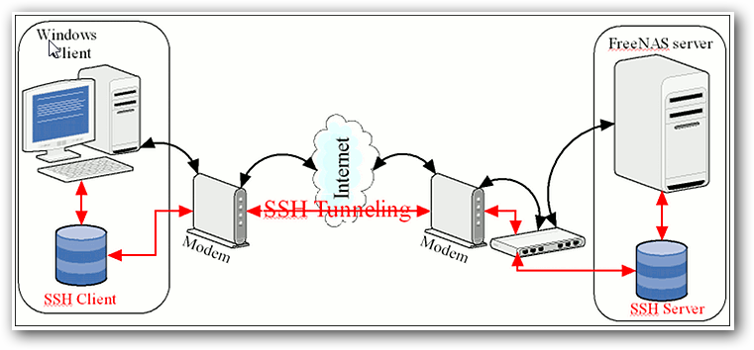

*Figure 3*: SSH platform-independent model

1. Security of SSH:

The [encryption](http://en.wikipedia.org/wiki/Encryption) used by SSH is intended to provide confidentiality and integrity of data over an unsecured network, such as the [Internet](http://en.wikipedia.org/wiki/Internet). SSH uses [public-key cryptography](http://en.wikipedia.org/wiki/Public-key_cryptography) to [authenticate](http://en.wikipedia.org/wiki/Authentication) the remote computer and allow it to authenticate the user, if necessary. Anyone can produce a matching pair of different keys (public and private). The public key is placed on all computers that must allow access to the owner of the matching private key (the owner keeps the private key secret). While authentication is based on the private key, the key itself is never transferred through the network during authentication. SSH only verifies if the same person offering the public key also owns the matching private key.[5]

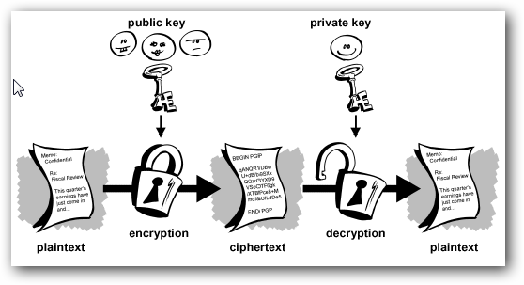

*Figure 4*: SSH encryption process

1. Source code examples
2. Example 1:
3. Example 2:
4. Example 3:
5. Example 4:
6. Examples of output
7. Output example 1:
8. Output example 2:
9. Output example 3:
10. Output example 4:
11. References

1 http://it.toolbox.com/blogs/enterprise-solutions/key-features-of-the-java-language-41397

2 <http://en.wikipedia.org/wiki/Write_once,_run_anywhere>

3 <http://www.anyang-window.com.cn/java-cross-platform-principles/>

4 http://boran.ch/security/sp/ssh-part1.html

5 <http://en.wikipedia.org/wiki/Secure_Shell>

<http://erpscan.com/wp-content/uploads/2011/05/09.png>

http://4.bp.blogspot.com/-VpNda7dWLpU/TmYn7PiFUVI/AAAAAAAAAQ8/FJmkiWEKxcE/s640/public_key_encryption.gif